**Spotify Revenue Distribution from 2019 - 2024 (in Million EUR):**

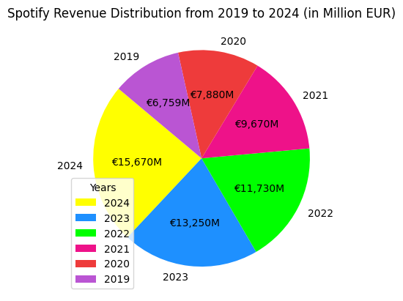

Detailed explanation:

The donut chart shows **Spotify’s total revenue** from **2019** to **2024**, combining earnings from both **ad-supported** and **premium subscribers**. The data highlights an upward revenue trend, with figures rising from **€6,759M** in **2019** to **€7,880M** in **2020**. A significant increase was recorded in **2021** **(€9,670M)**, followed by **€11,730M** in **2022** and **€13,250M** in **2023**. The highest revenue, **€15,670M**, was achieved in **2024**. The color-coded sections help differentiate each year’s revenue, making financial growth easily visible.

Key statement:

The steady increase in total revenue underscores Spotify’s balanced approach between free and premium users. The consistent rise indicates a successful strategy in expanding its user base while strengthening its revenue streams.

Additional input:

A possible reason for the sharp rise in revenue between 2020 and 2021 could be the **COVID-19 pandemic**. During the lockdown periods, people from all over the world turned to music streaming platforms to cope with **isolation** and **boredom**, leading to an increase in both free and premium users.